Learning Journal

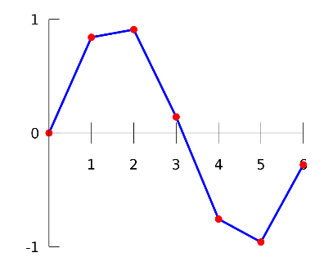

Camera Controller (<https://www.youtube.com/watch?v=blO039OzUZc>) – For the Camera Controller one thing I learned was how to use Mathf.Lerp to animate a gameobject between 2 points. Interpolation has 2 points: One, which is the start position of the gameobject and the second, which is where you want the gameobject to be animated to. Unity essentially fills in the data gaps between these two floats and animates the object in between these points. I also learned how to use the Quaternion.AngleAxis(#, Vector3) Function which sets the objects current rotation to a new rotation using the float provided around the axis of the Vector provided. This is what I used to transform the camera and players rotation after I had calculated the mouse move values.

Lasers – One thing I learned while trying to create the Lasers was how to use and understand the Animator a bit more. I learnt that you can pause animation by setting the Animator speed to 0.

Player Controller – A big thing I learnt when programming my Player Controller was about the Character Controller component built into Unity. This component is great if you don’t want to use Rigidbody for whatever reason such as wonky physics or the floaty feel it generally has. The Character Controller is tougher to use, however, because you must code in things like gravity yourself and player movement is slightly longer winded due to not being able to edit the velocity like in a Rigidbody and instead having to use specific Character Controller functions. Another thing I learnt was how to use Coroutines which are separate methods that can be called at any time and are useful because you can put code breaks in for however long you want to delay certain actions.

Jump Pad – The main thing I learnt when coding my Jump Pads was how to reference other scripts correctly and apply new values to variables in those other scripts.